Job – 7
Aim: To document the process of installing Pop!_OS alongside an existing Windows installation, allowing the user to choose which operating system to boot into.
Software Required:
- A computer with Windows already installed.
- A USB drive with at least 8GB of storage.
- BalanEtcher or Rufus for creating a bootable USB drive.
- Pop!_OS ISO file (Nvidia version if applicable)

Procedure:
Part 1: Preparing Windows
1. Back up your data: Before making any changes, back up all important files from your Windows installation.
2. Create free space for Pop!_OS:
- Open "Disk Management" in Windows.
- Right-click on your main Windows partition (usually C:) and select "Shrink Volume".
- Enter the amount of space you want for Pop!_OS (at least 20GB, 100GB or more is recommended).
- Click "Shrink". This will create "Unallocated" space.
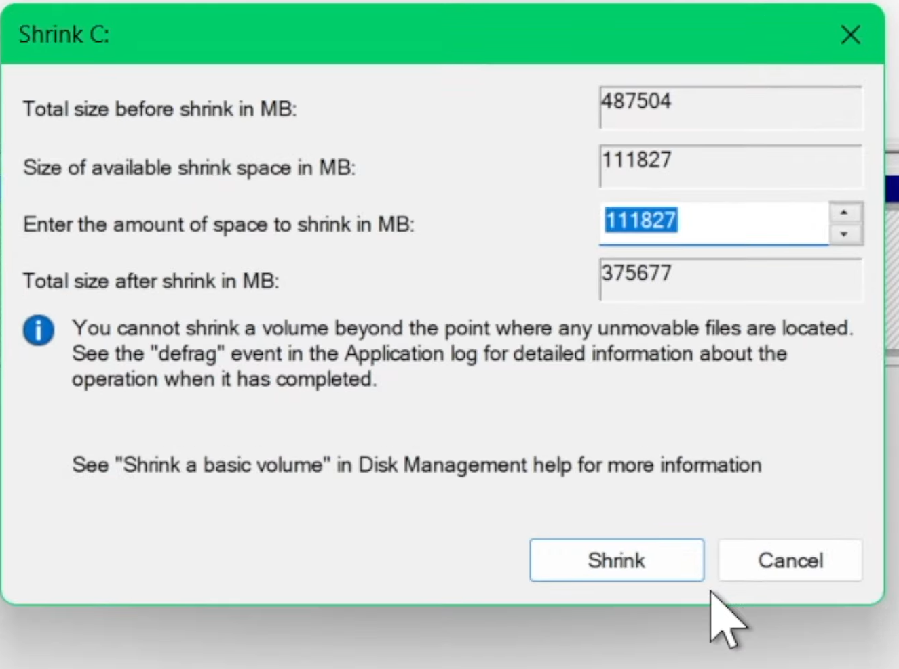
Figure 1 Disk Management
3. Disable Fast Startup:
- Go to Control Panel > Hardware and Sound > Power Options > Choose what the power buttons do.
- Click "Change settings that are currently unavailable".
- Uncheck "Turn on fast startup".
- Save changes.
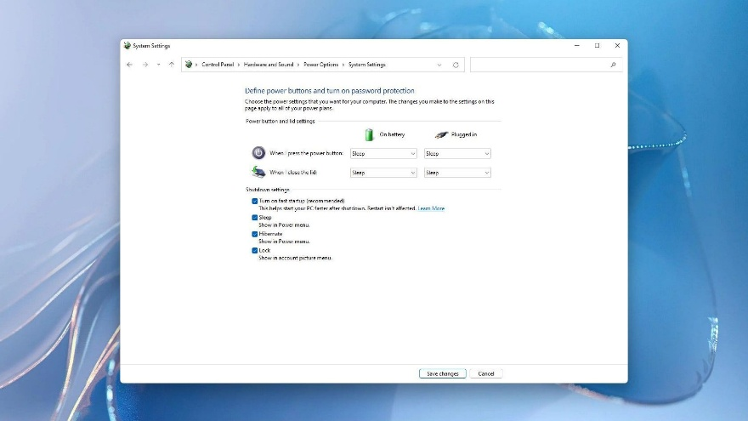
Figure 2 Disabling fast startup
Part 2: Creating a Bootable USB
- Download Pop!_OS: Get the appropriate ISO from the official System76 page.
- Create bootable USB: Use balenaEtcher to flash the ISO to your USB drive.
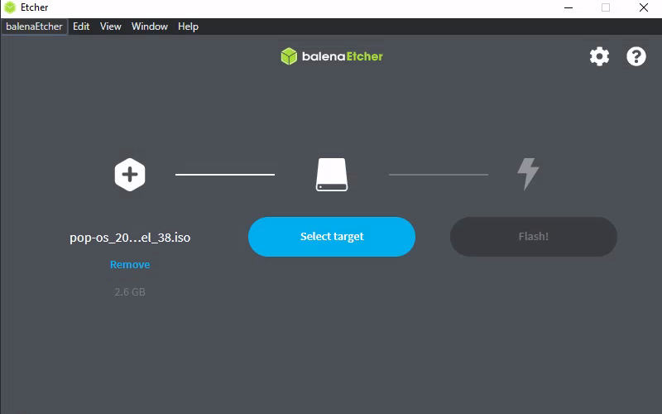
Figure 3 Flashing ISO to USB drive

Part 3: Installing Pop!_OS
- Boot from USB:
- Restart your computer and enter the BIOS/UEFI settings.
- Disable "Secure Boot".
- Set the USB drive as the primary boot device.
- Save changes and exit.
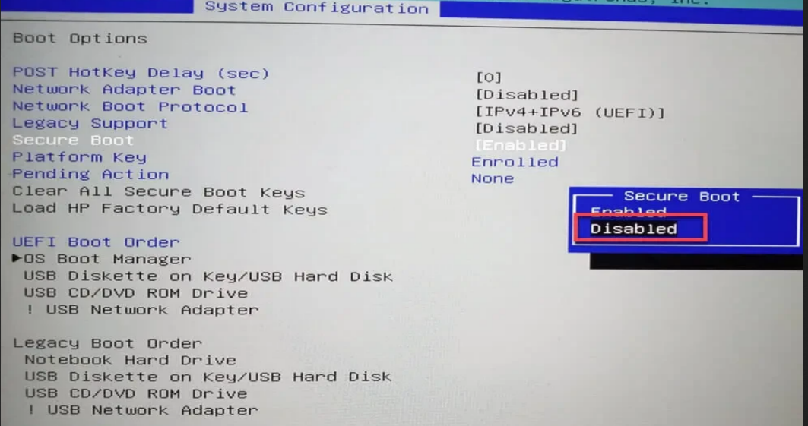
Figure 4 Disabling Secure boot
- Start Installation:
- Boot from the USB drive and select "Try or Install Pop!_OS".
- Choose your language and keyboard layout.
- Select "Custom (Advanced)" when asked for the installation type.
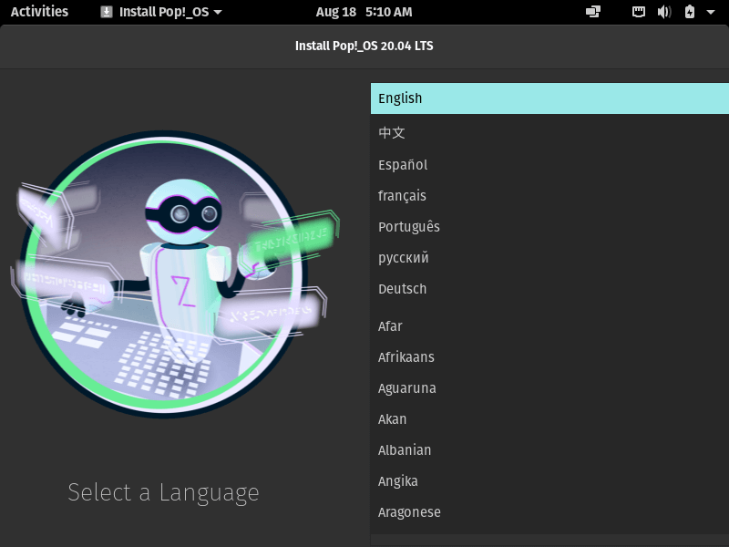
Figure 5 Choosing Language
- Partitioning:
- You will see the "Unallocated" space you created. You need to create a few partitions in this space.
- EFI System Partition:
Size: 512 MB
File System: FAT32
Mount Point: `/boot/efi`
- Root Partition:
Size: At least 20GB (100GB+ recommended)
File System: ext4
Mount Point: ` /`
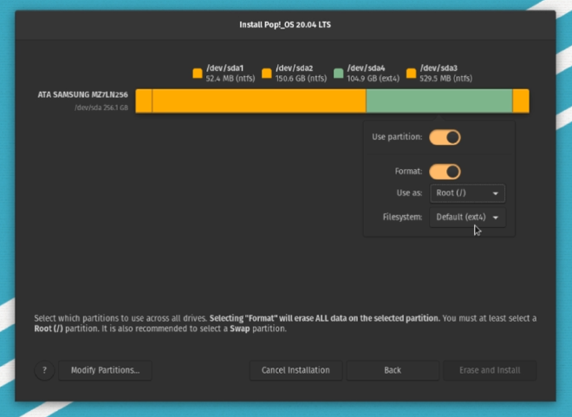
Figure 6 Partitioning the unallocated space

- Complete installation:
- Apply the changes and continue with the installation.
- Create your user account.
- Restart when prompted and remove the USB drive.
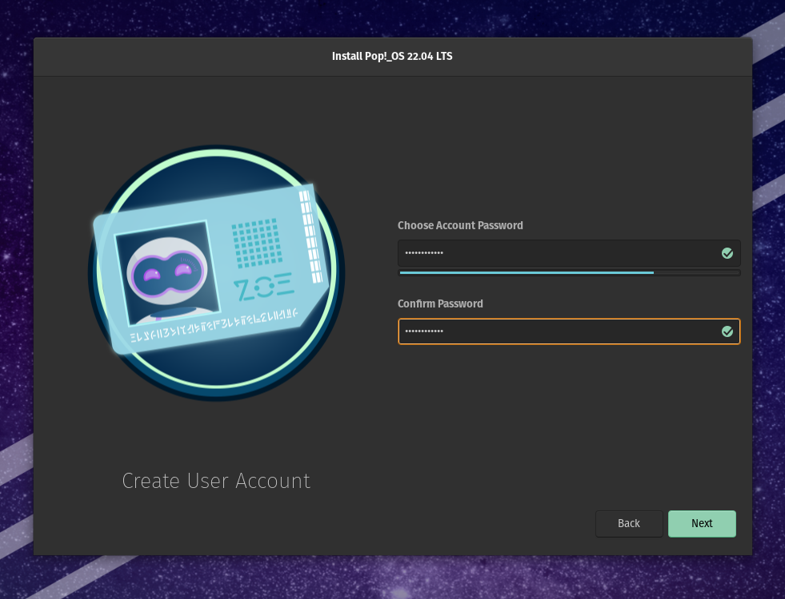
Figure 7 Creating a local account

